**Meeting 17/02/21 Notes**

* Results below found and discussed. Finished sentiment analysis showing it has definitely picked up on some words that are more likely to make a male/female annotator label the comment toxic. This proves that there is a difference between annotations made by men and women and this can be picked up on by a machine learning model, highlighting the importance of diversity of opinion.
* For next week train the model separately on male and female data to predict toxicity, test on male/female/both toxic data for both cases. Get degree of agreement between models. Look for: men missing toxicity of sentence women predicted toxic, see whether female model can generalise better to male data than other way around (predicts with high accuracy), would women agree with men on toxicity of sentences?
* Look at offensive words (will be sent list). Score comments based on count of offensive words. If no offensive words does male classifier still find toxic? Study correlation between number of offensive words and male/female annotation.
* Want more in-depth analysis and validation, investigate multiple methods to see if get same conclusion (cross-validate).
* Begin to write paper – introduction and literature review (write in such a way that it can be recycled for full published paper). Focus on gender bias in annotation.
* Next step: mask offensive words and retest model.
* Think about poster, create an interface like a game – guess the gender of the annotator then show the words that contributed to the decision of the classifier. Pick examples where true and predicted labels disagree. Think of catchy title. Animate poster, use interactive shading, or embed interface and then use static copy for submission. Likely have a few mins to pitch poster and then there will be breakout rooms to discuss.
* Do mock oral presentation with PhD student – will help with questions and coming up with more ideas for slides.

**This week’s results:**

In Toxic_BERT_Sentiment.ipynb (with MAX_LEN = 100):

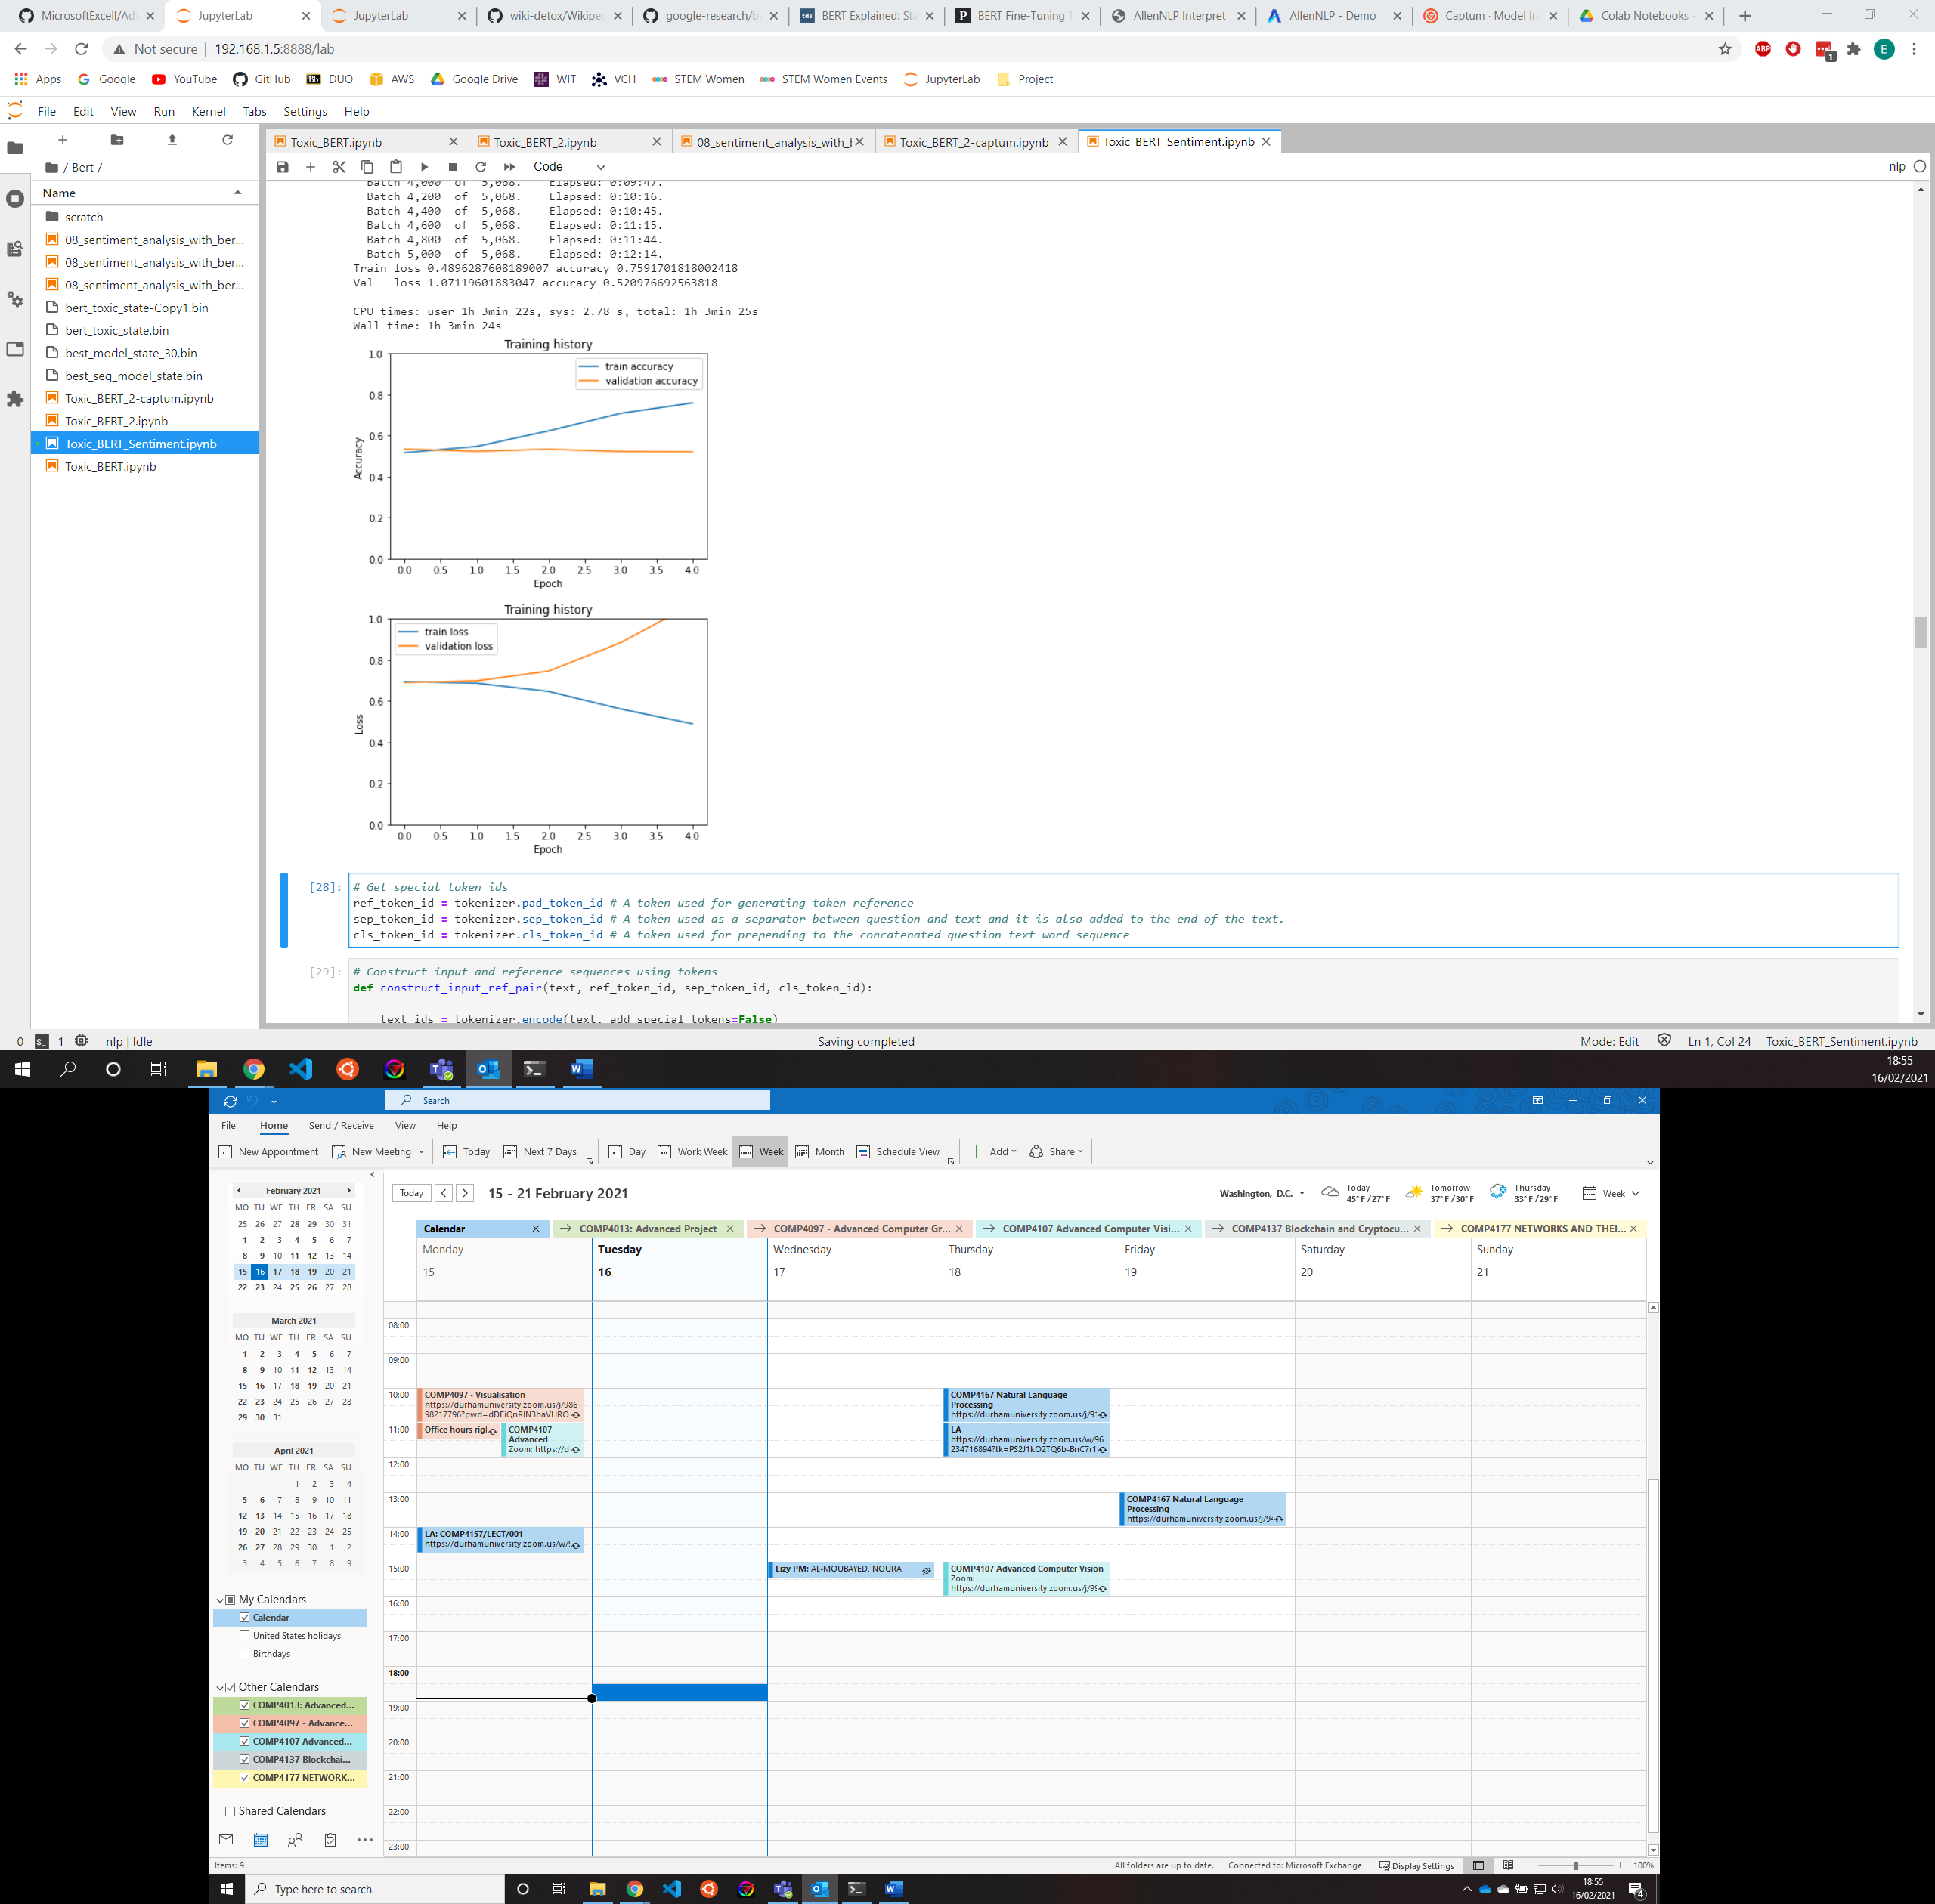

Loss and accuracy graphs over 5 epochs – overfitting?

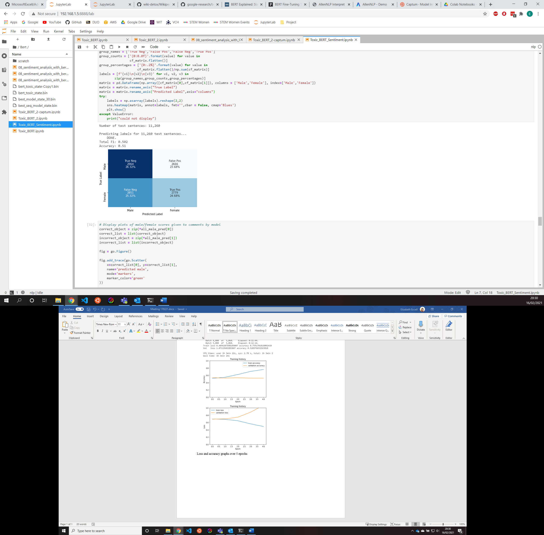

Overfitting – can see from previous graphs

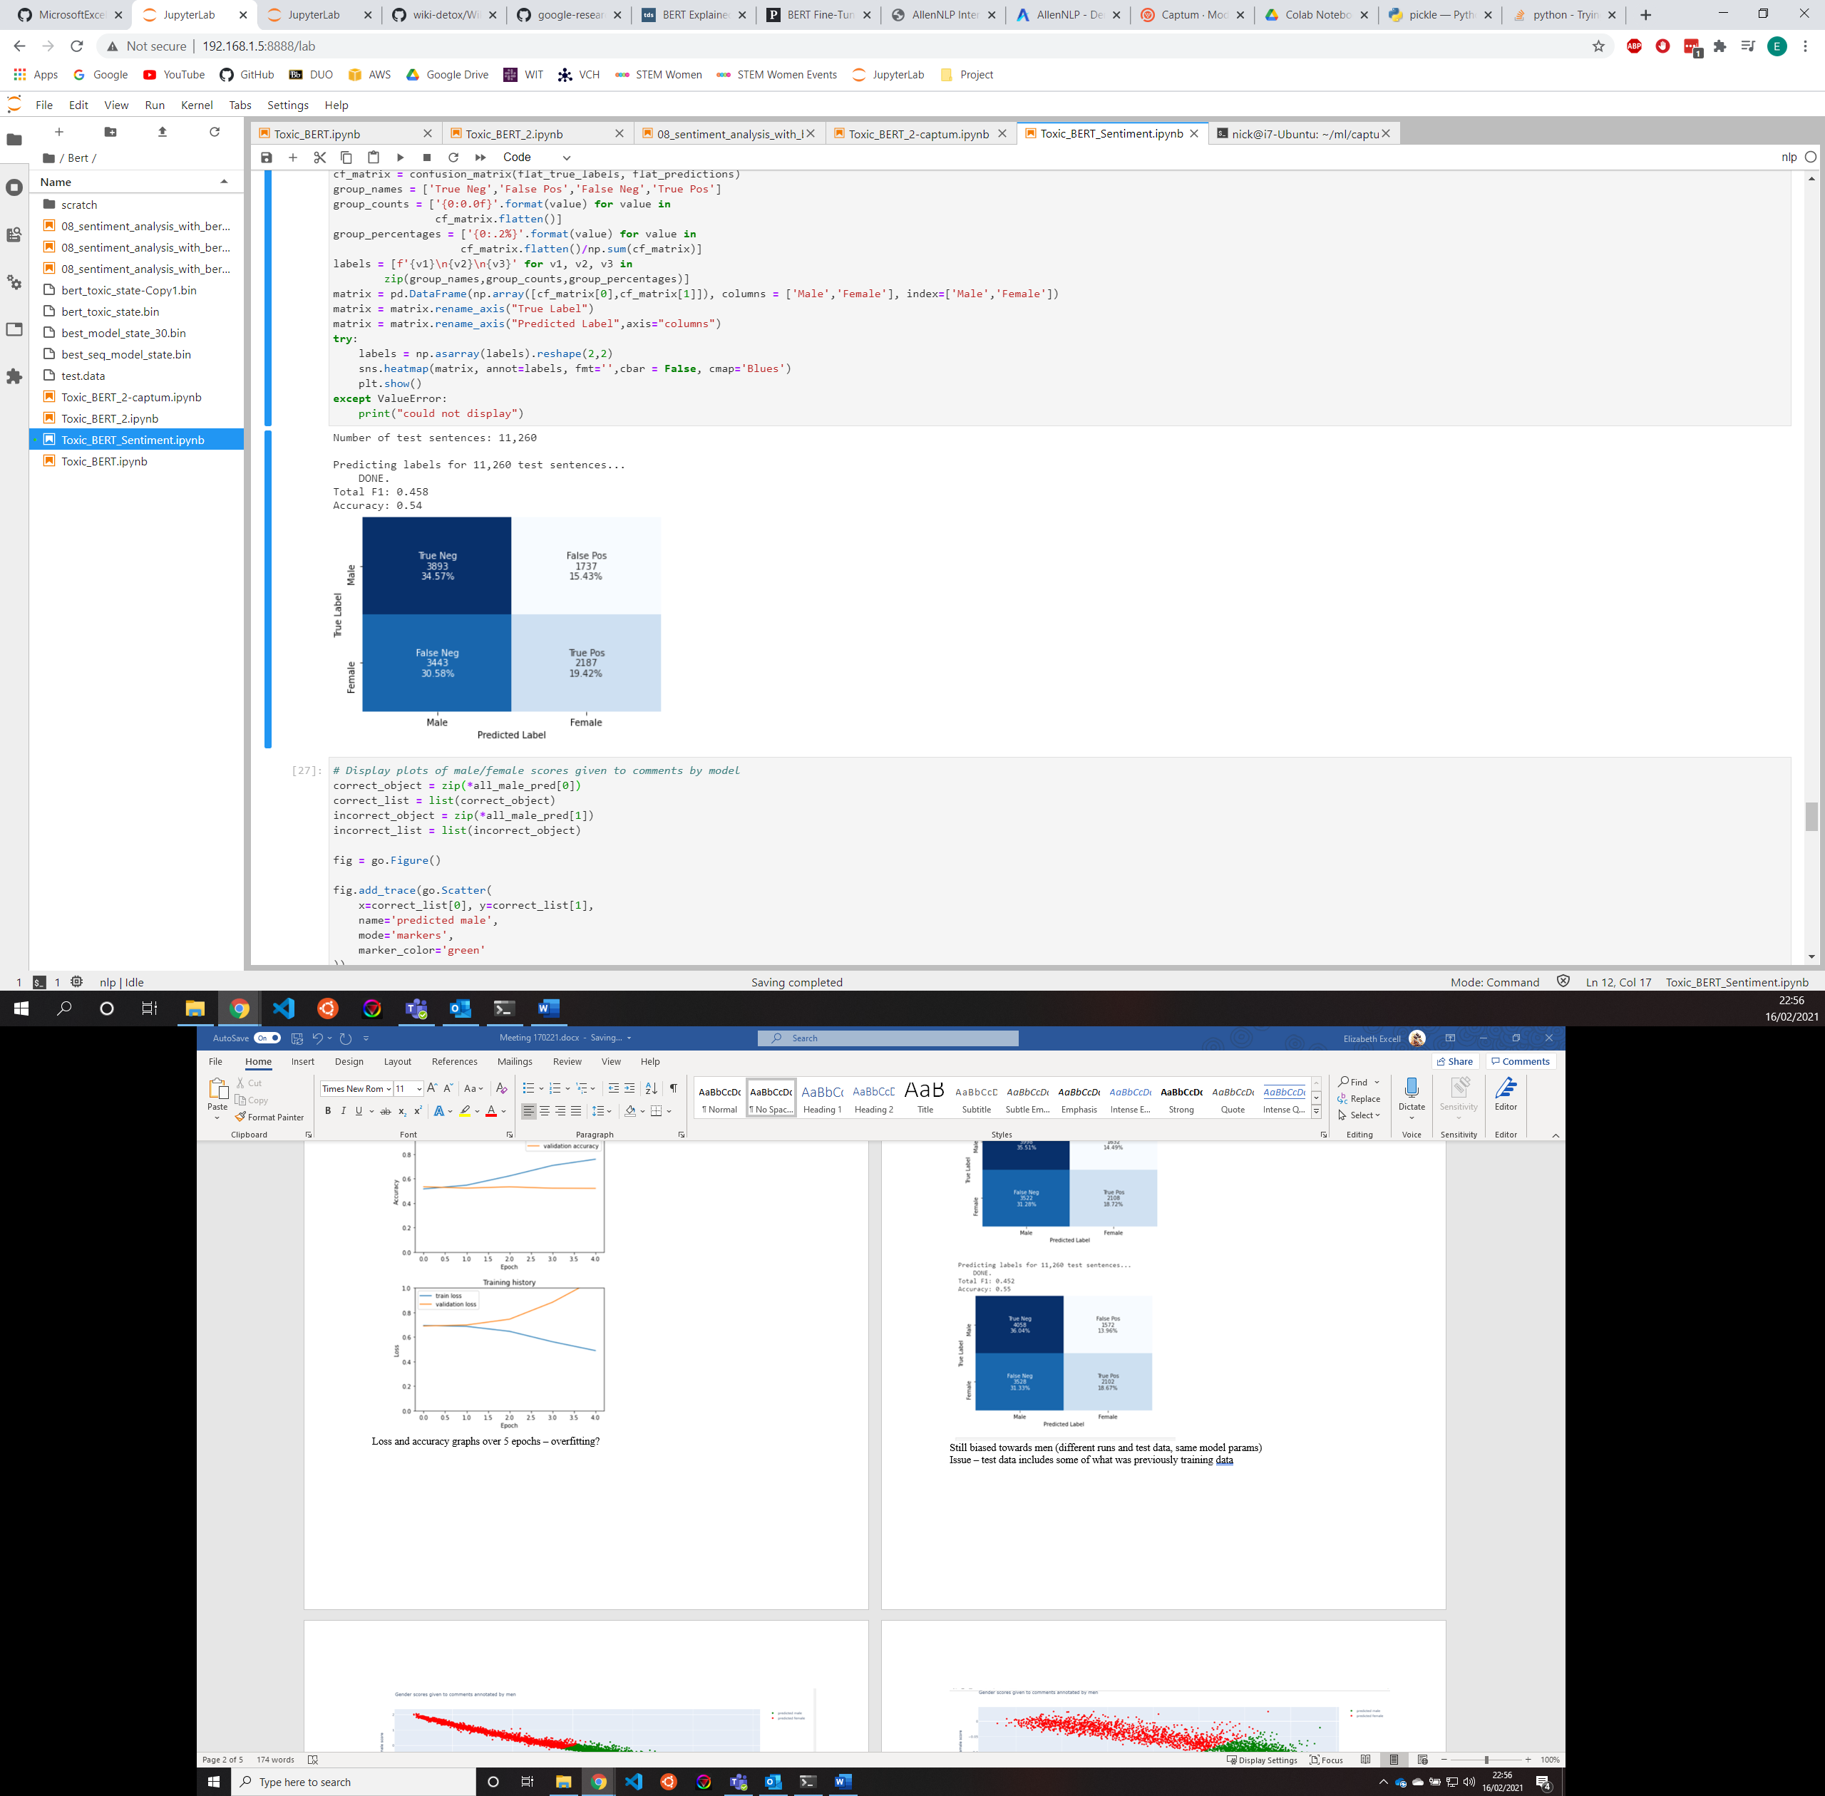

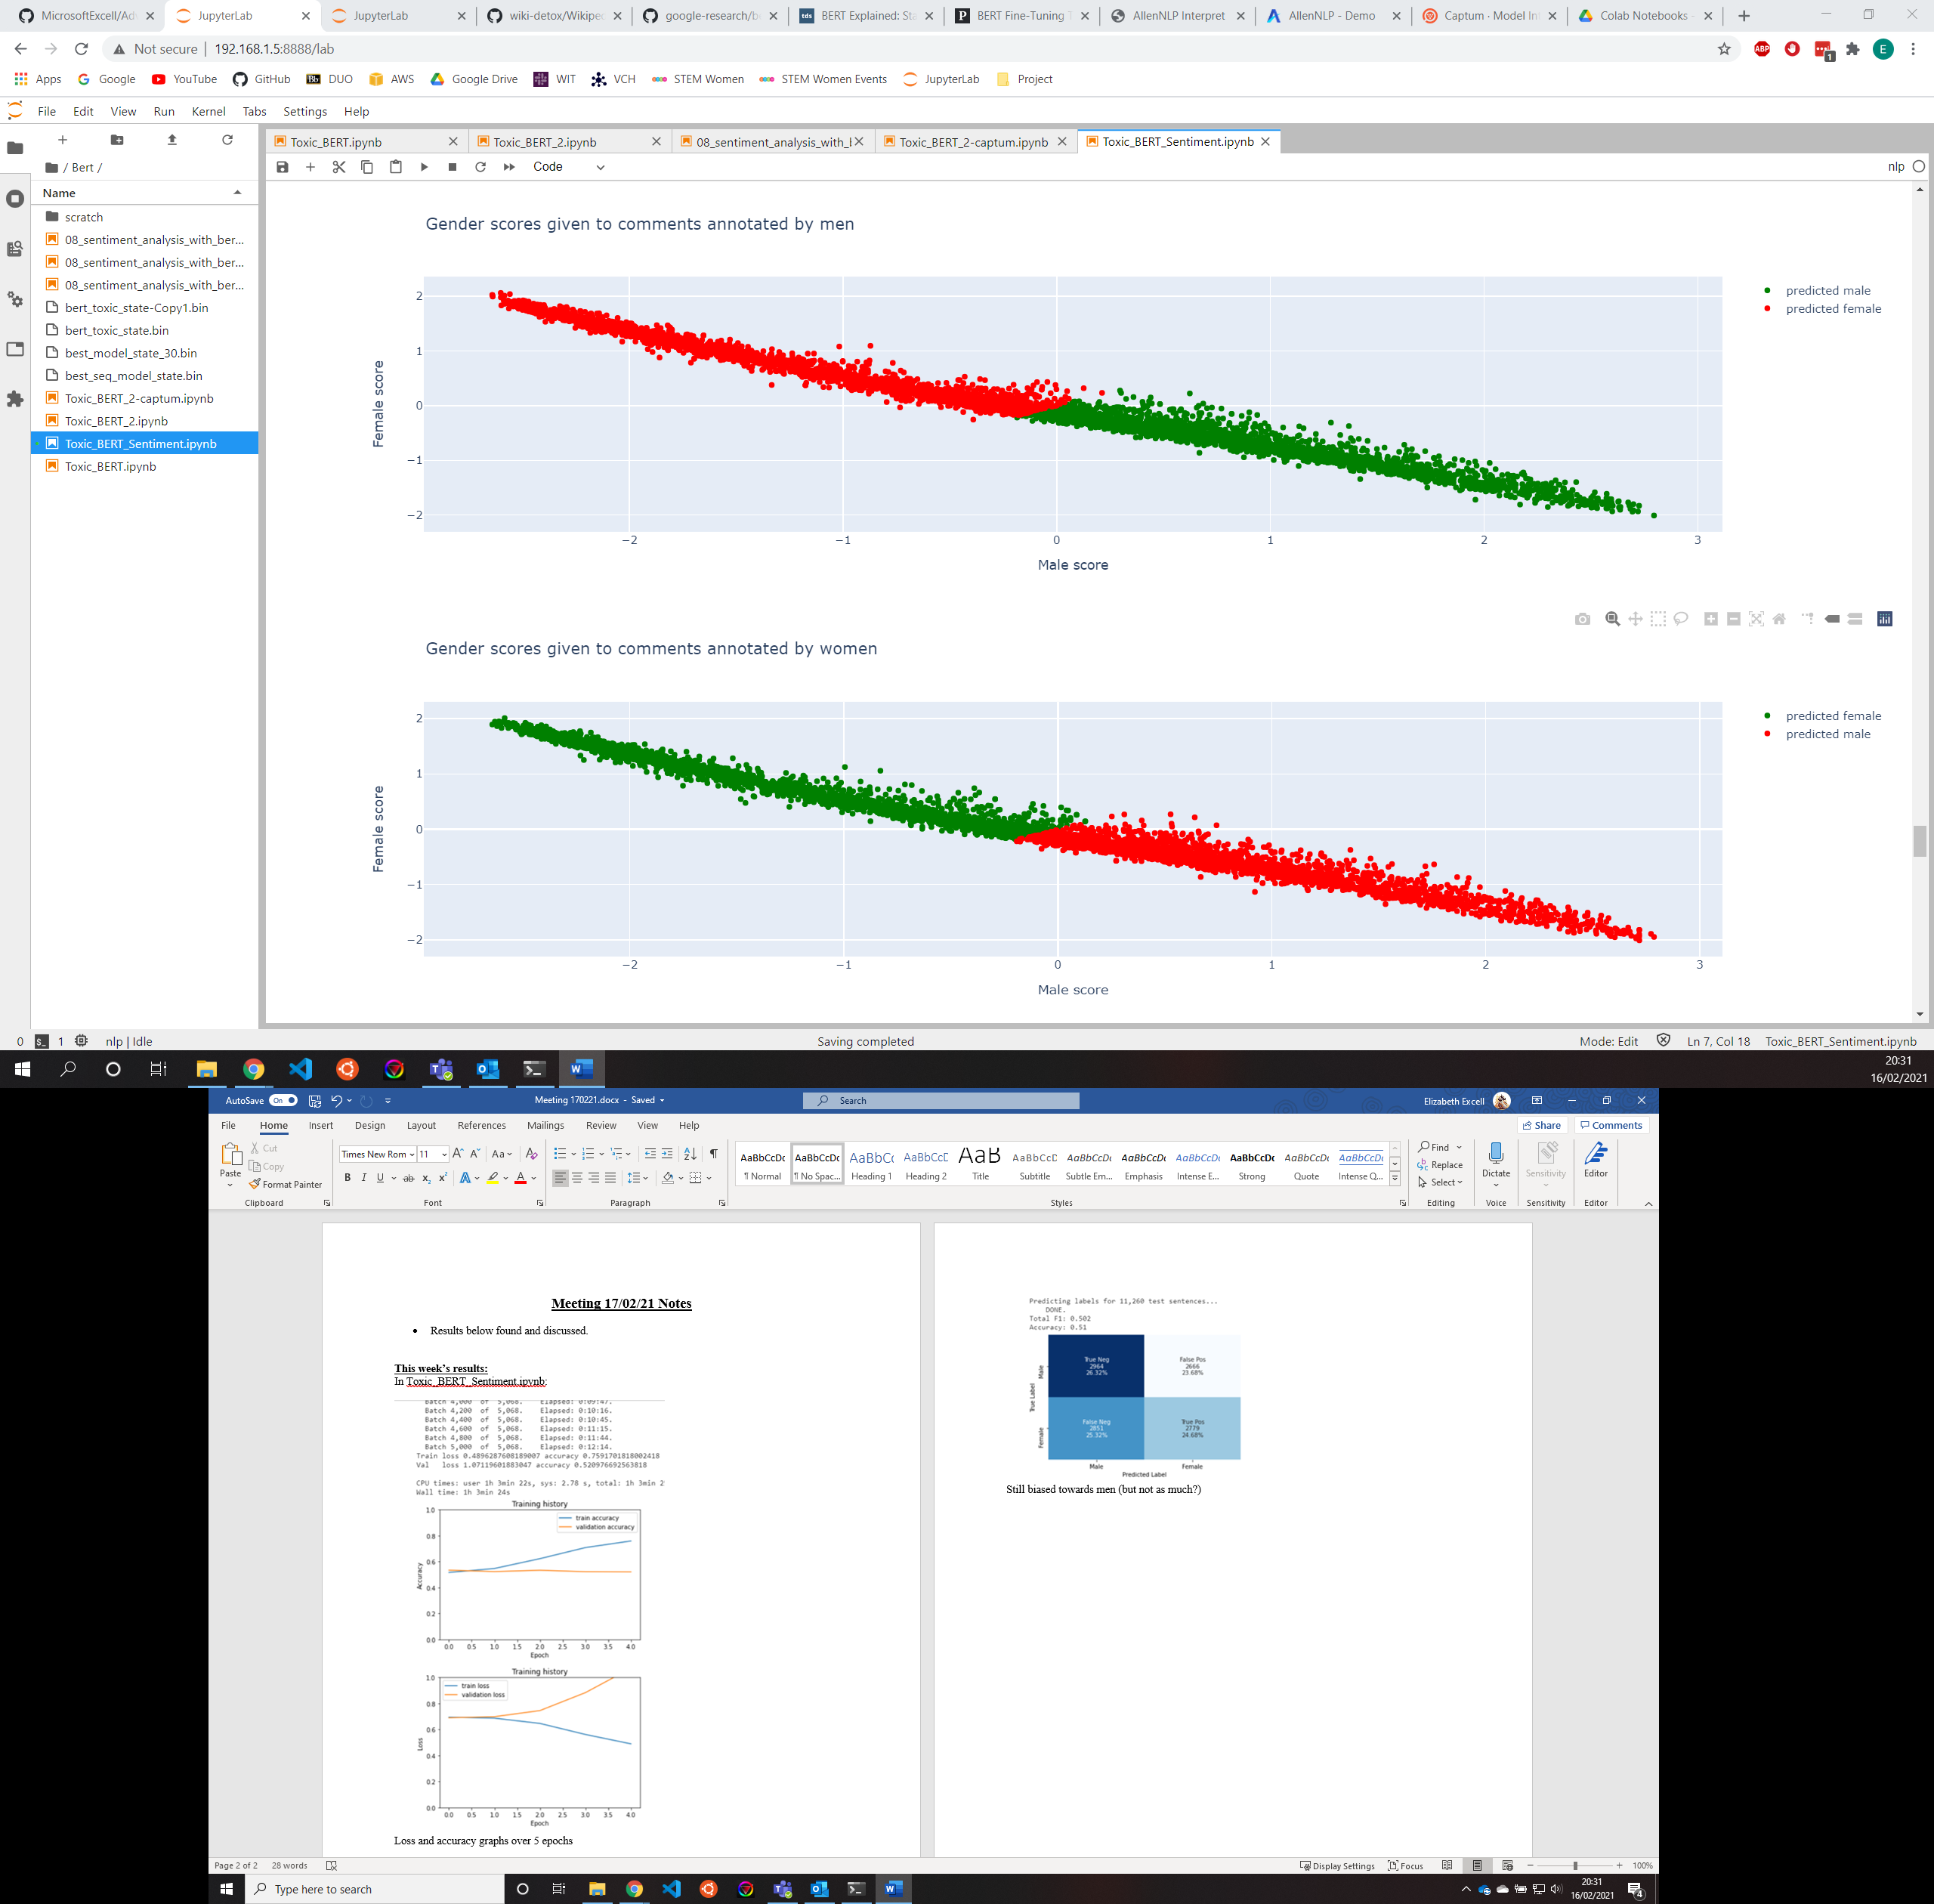

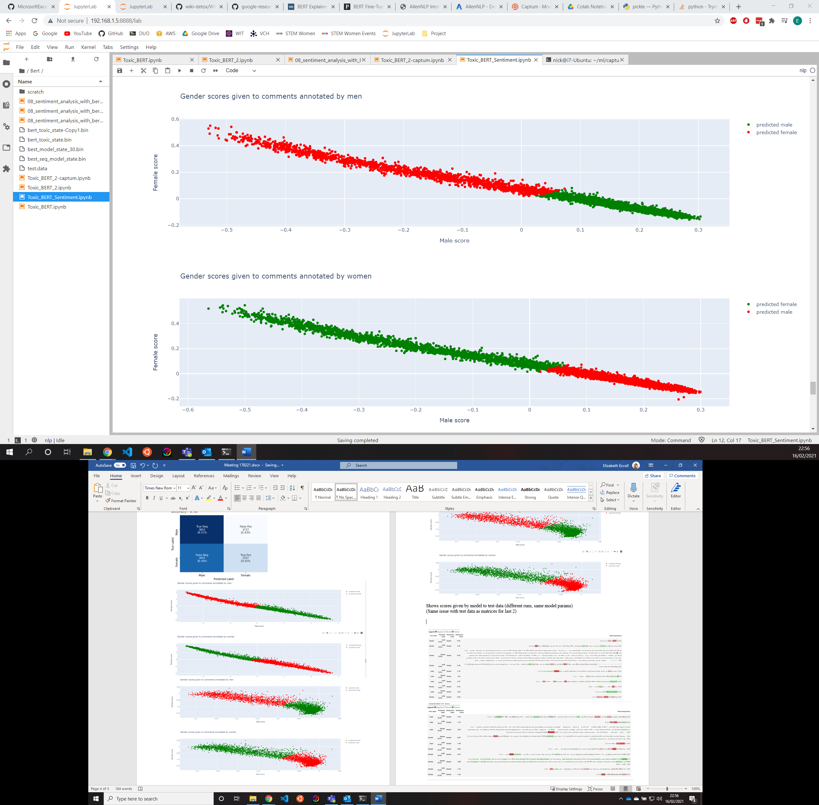

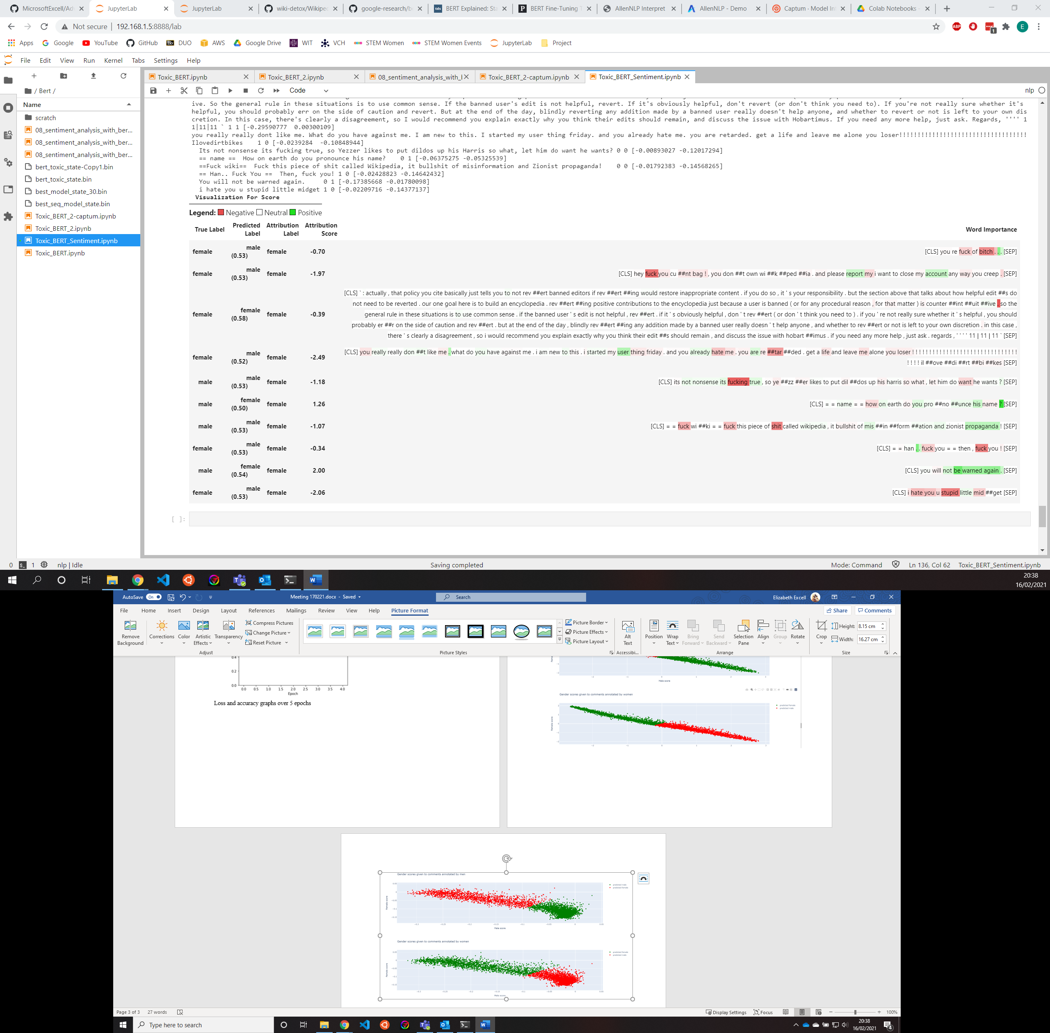

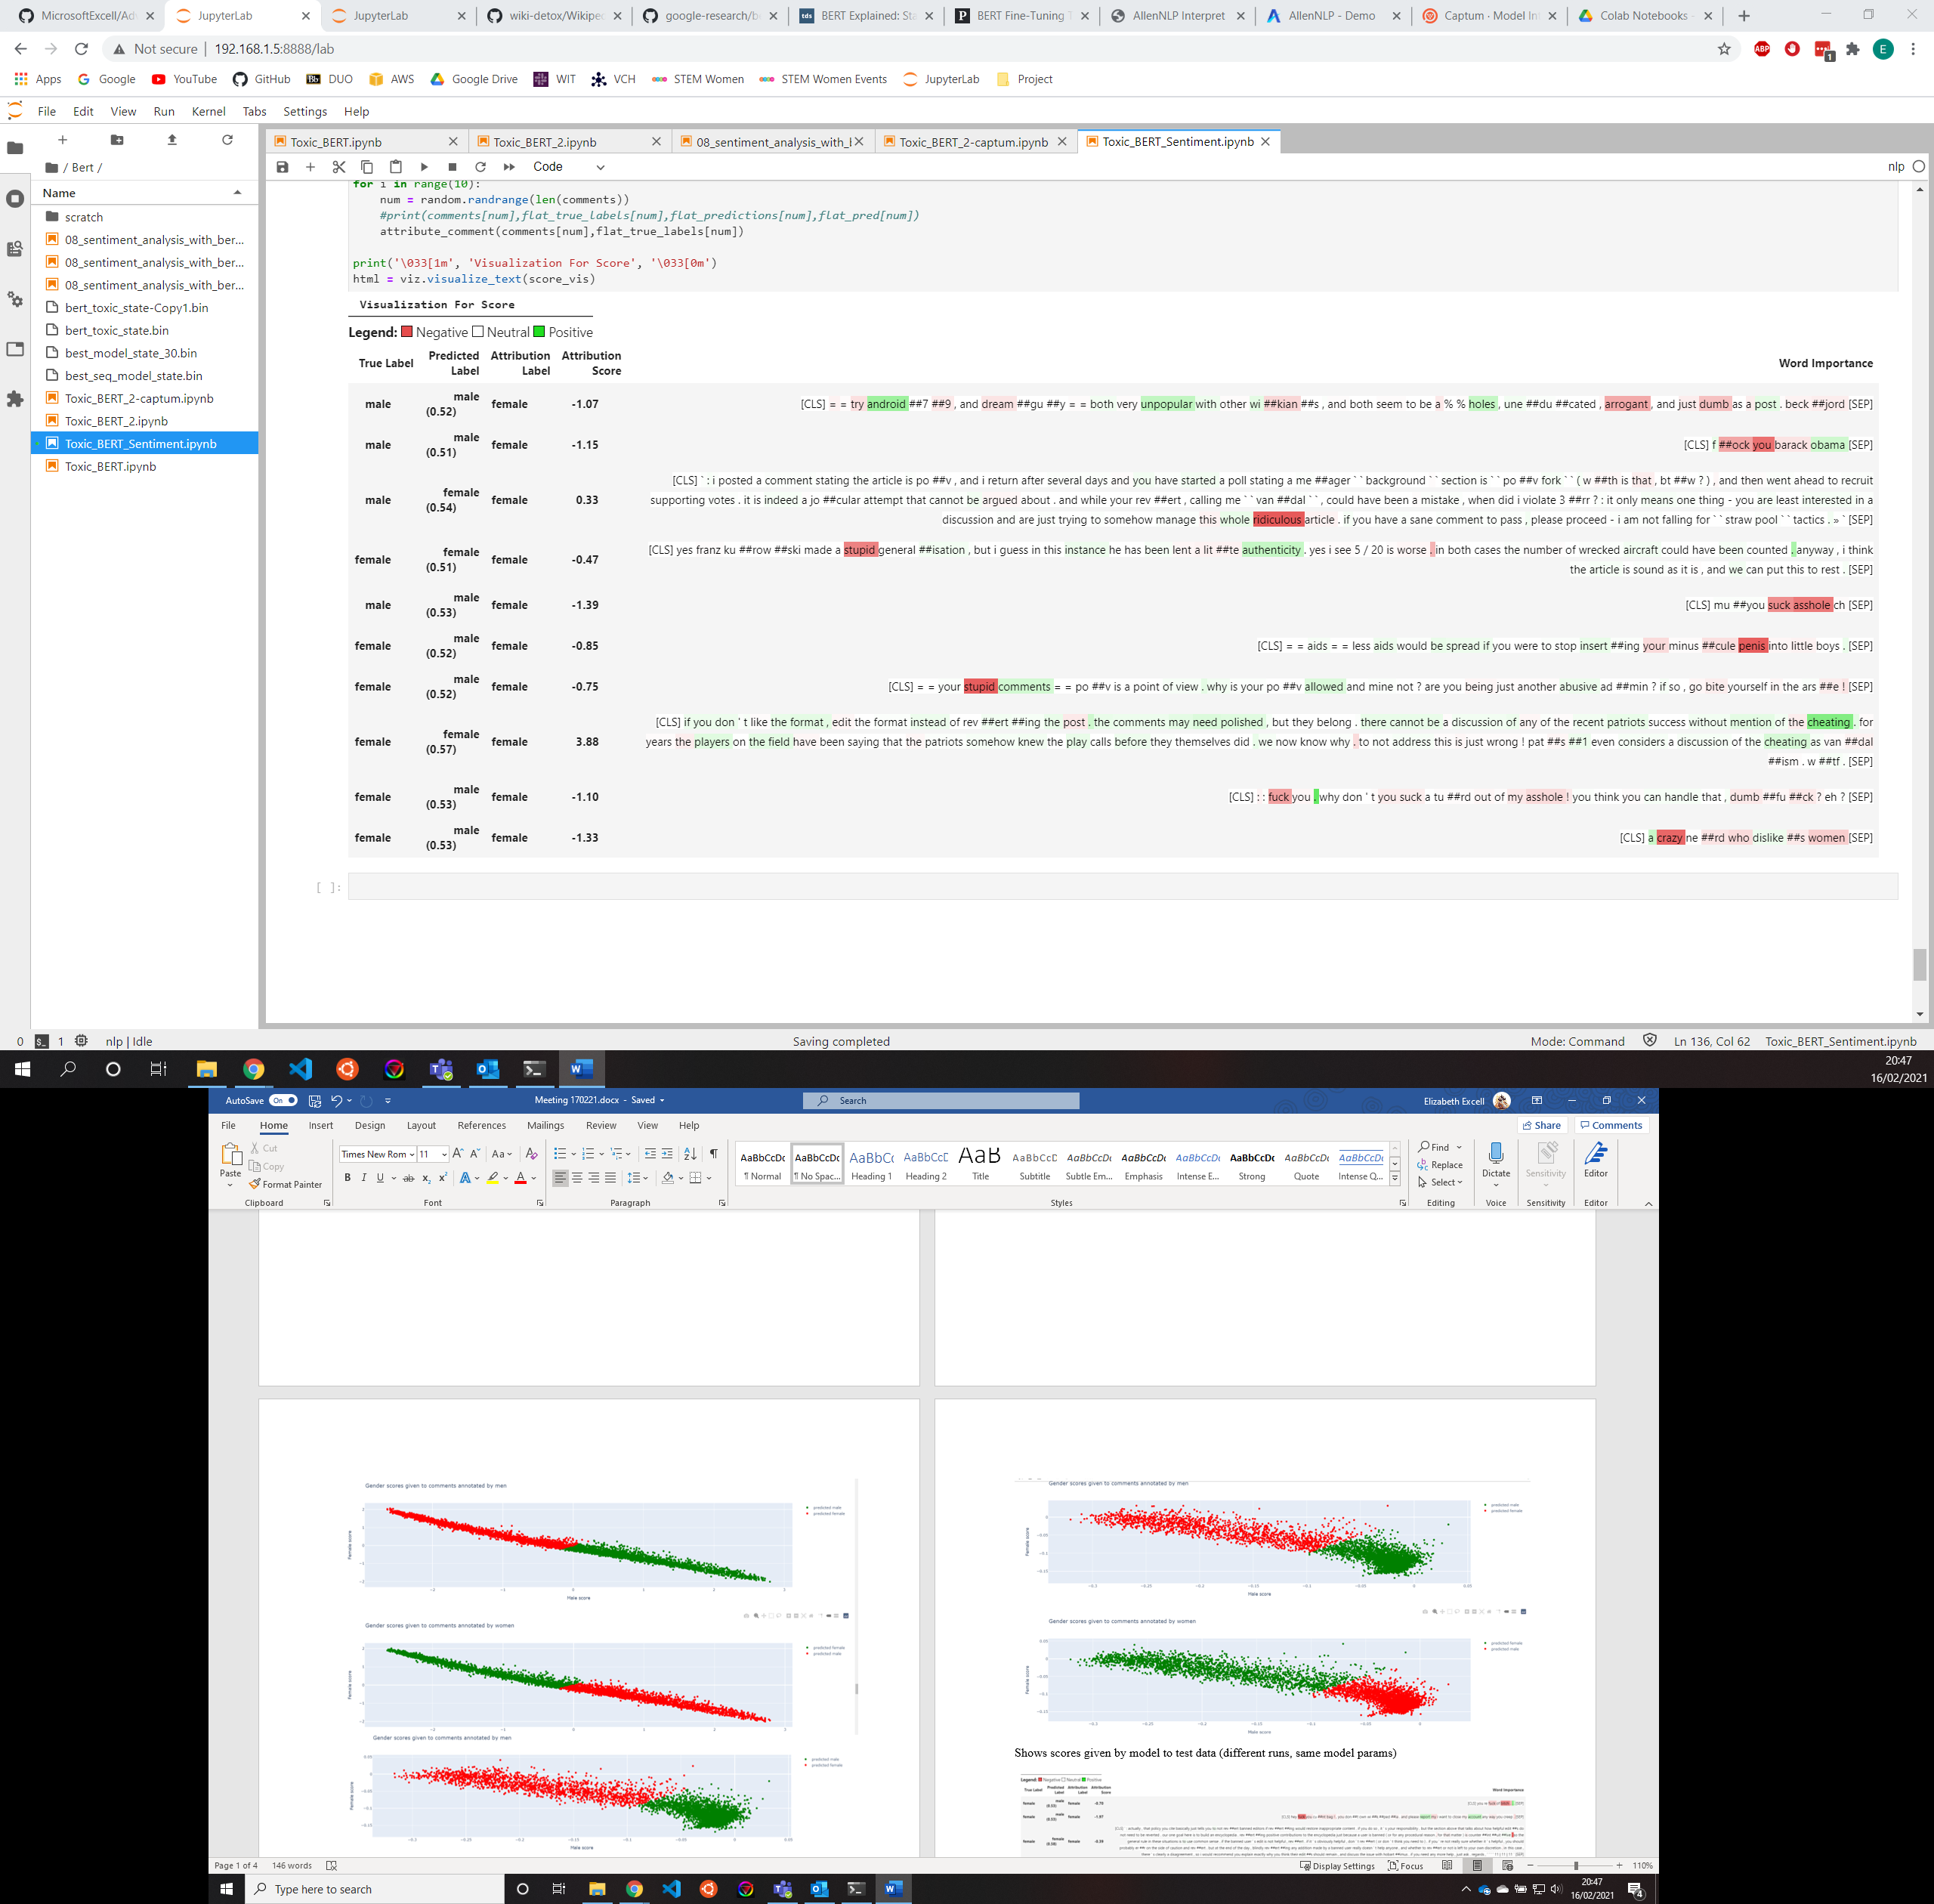

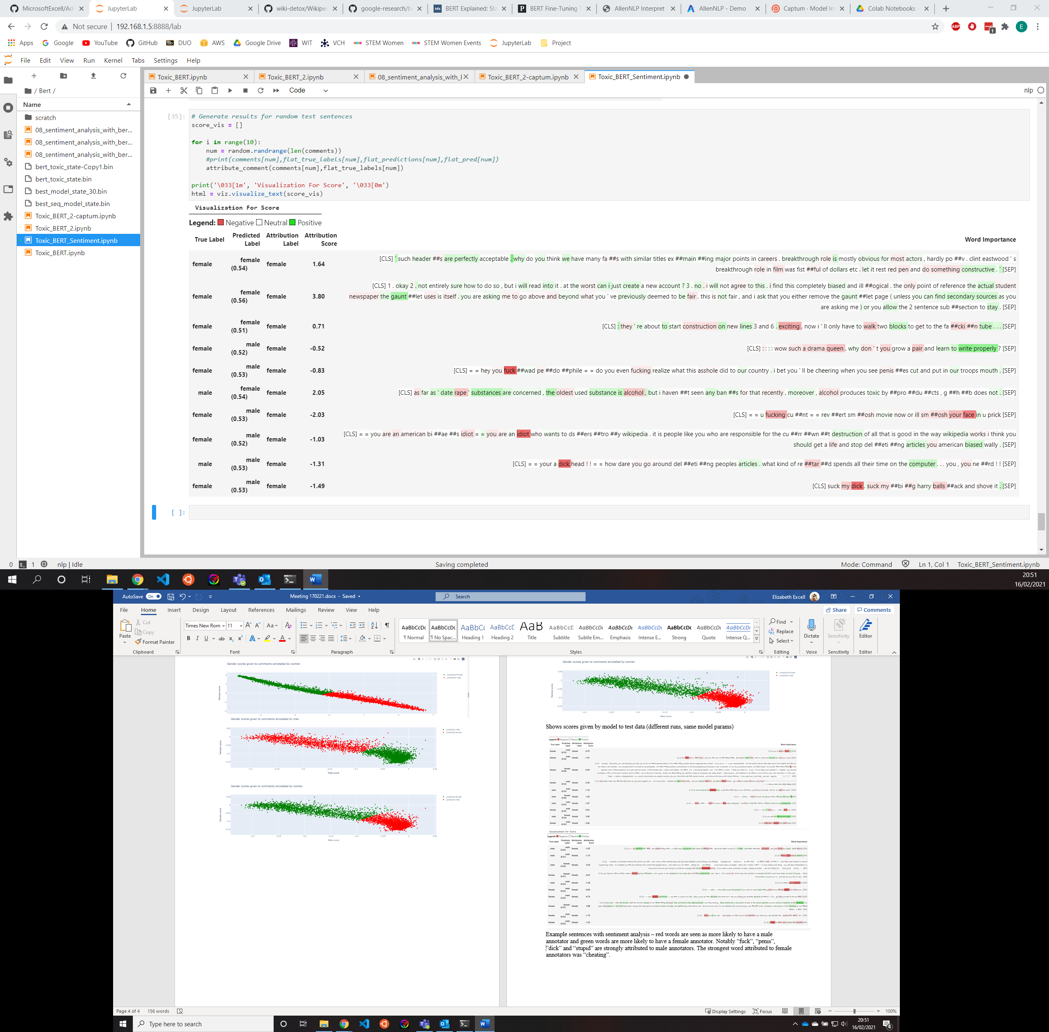

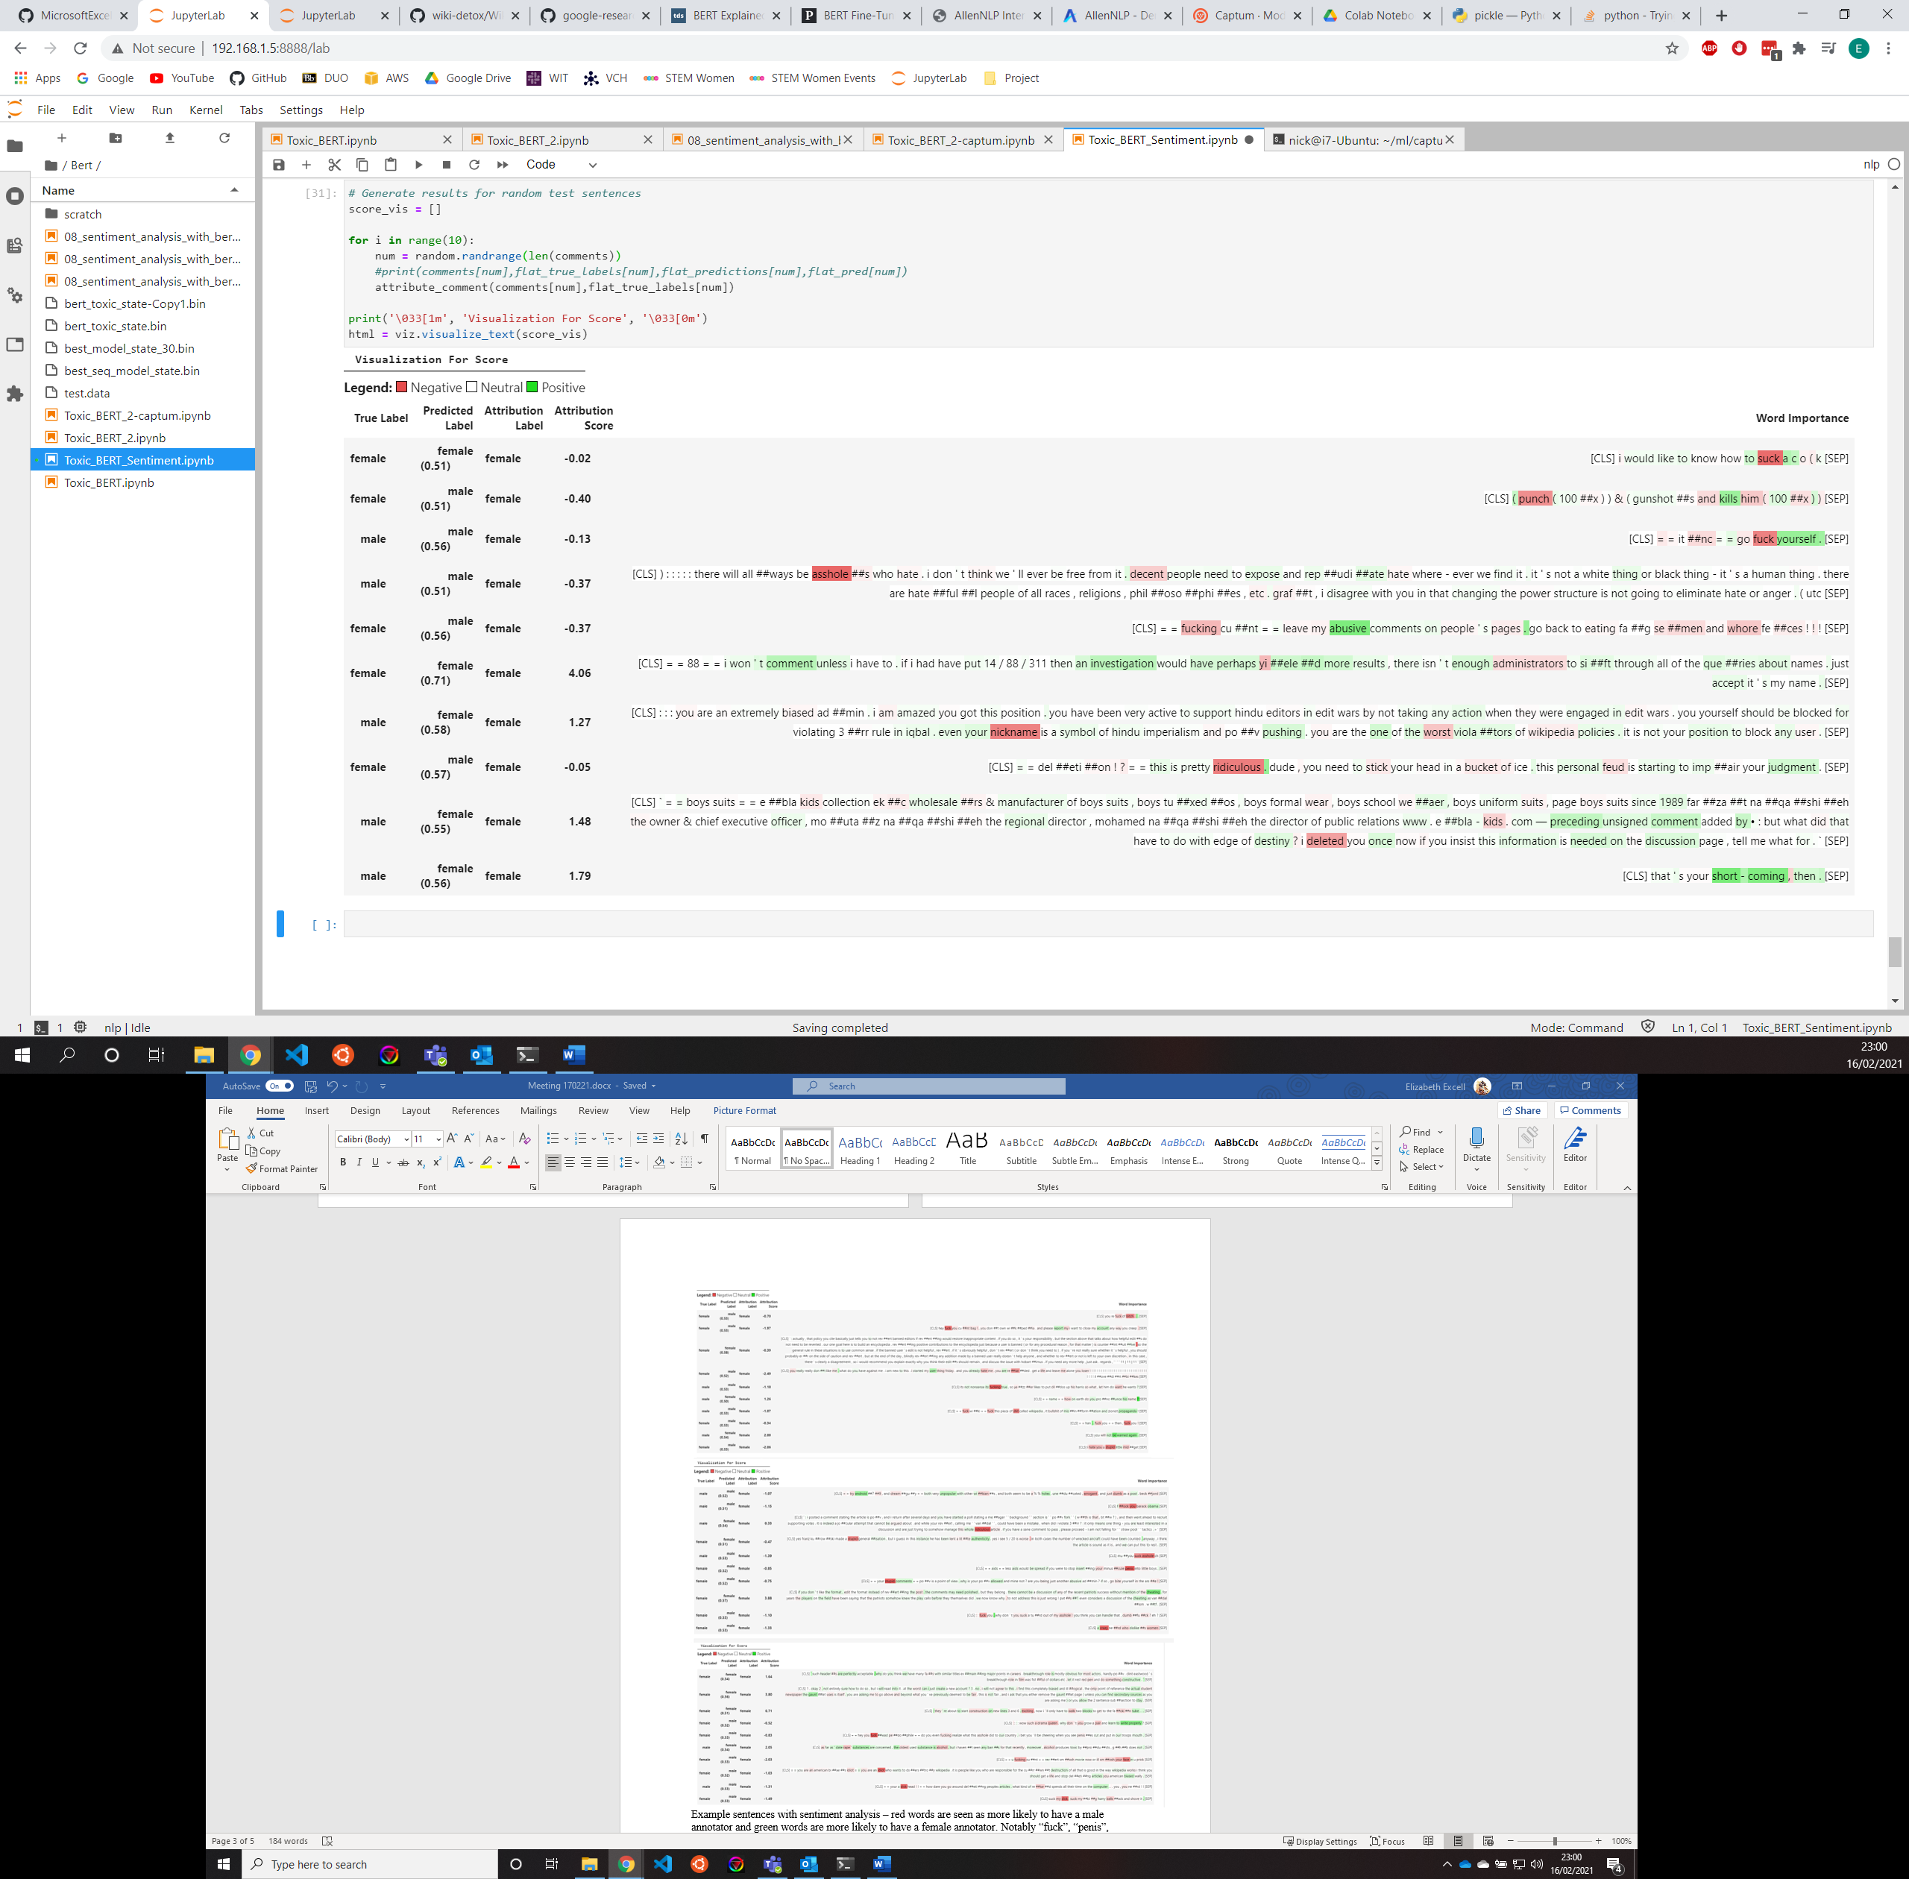

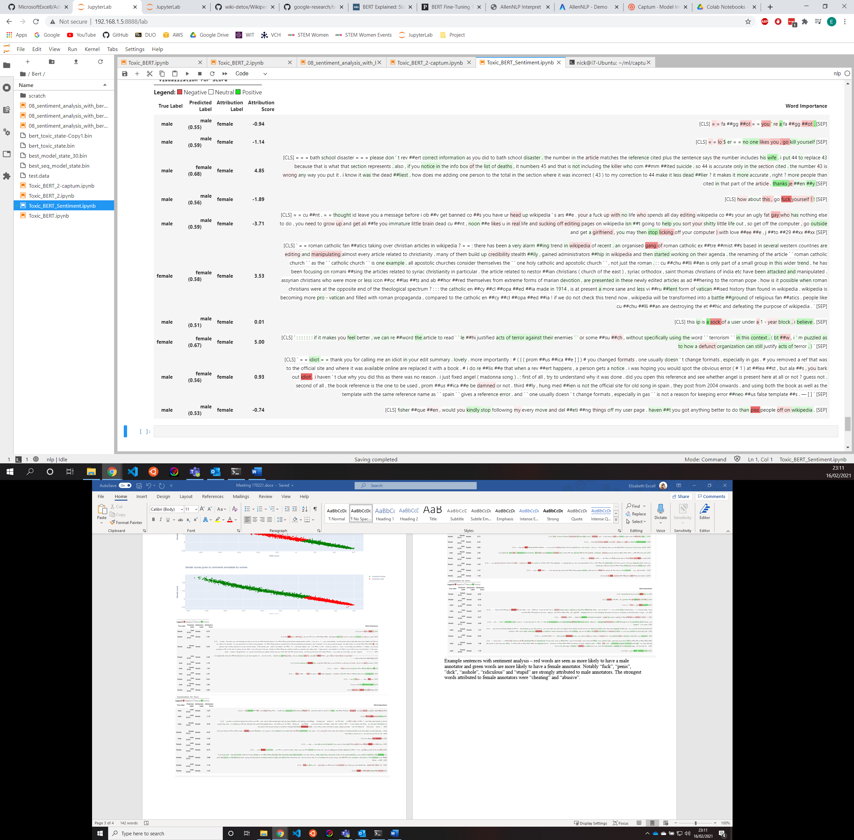

Example sentences with sentiment analysis – red words are seen as more likely to have a male annotator and green words are more likely to have a female annotator. Notably “fuck”, “penis”, ”dick”, “asshole”, “ridiculous” and “stupid” are strongly attributed to male annotators. The strongest words attributed to female annotators were “cheating” and “abusive”.